Violent Crime Rate:
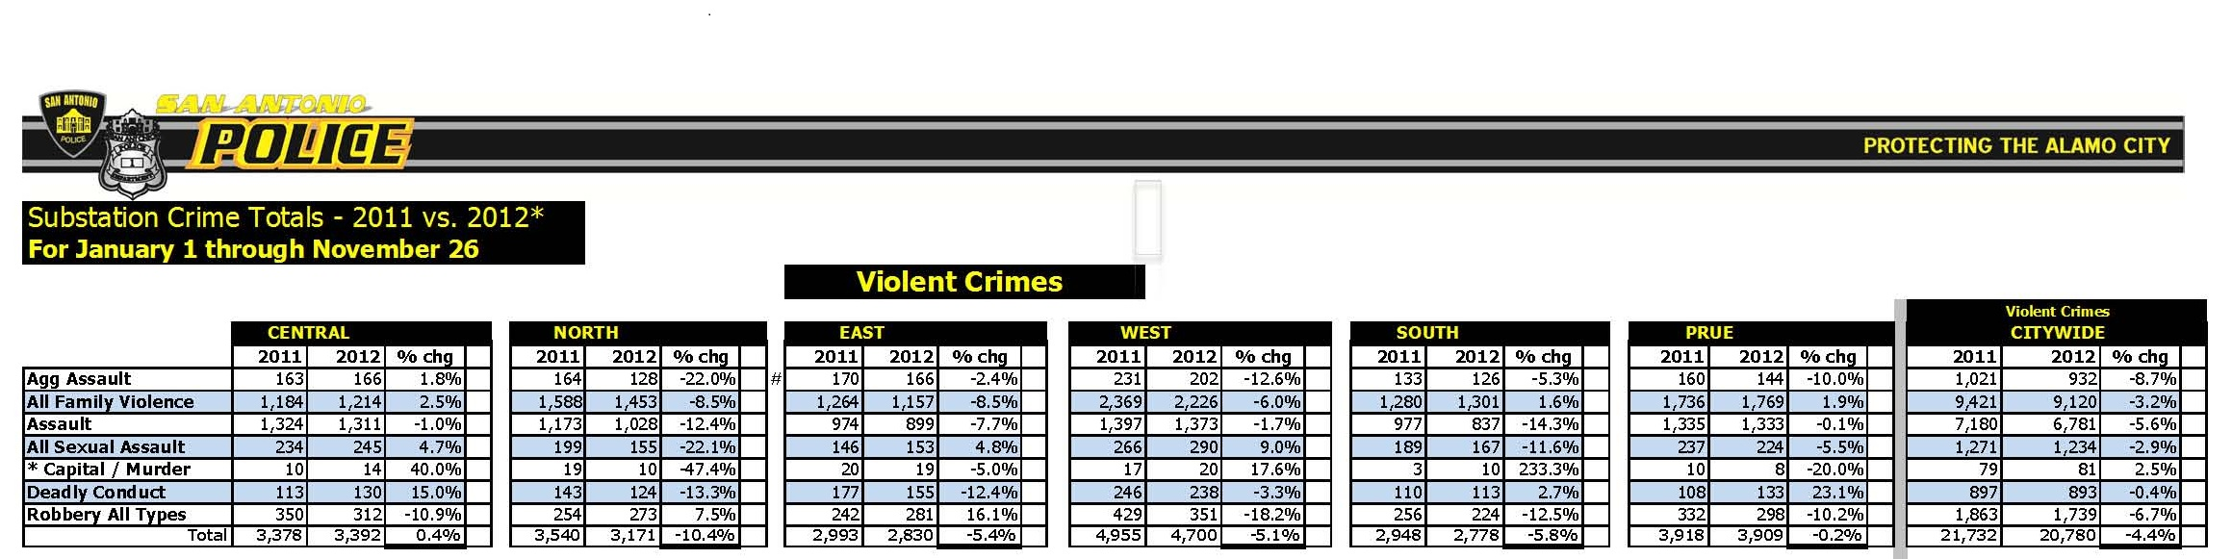

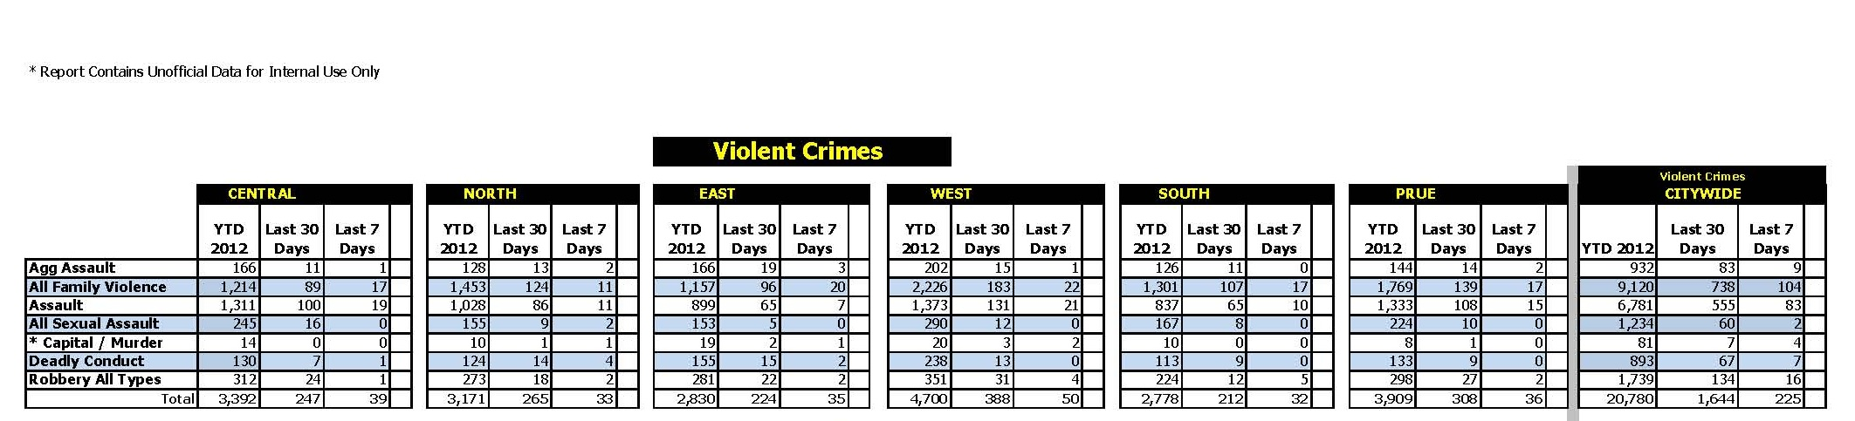

Data Source: San Antonio Police Department Strategic Intelligence and Analytics,
Link: sanantonio.gov

Offenses Known to Law Enforcement - Violent Crime by City (Bexar County) 2011
City | Population |  | Violent Crime | Murder and non-negligent manslaughter |  | Forcible Rape | Robbery |  | Aggravated Assault
Alamo Heights |  | 7,179 | 4 | 0 | 1 |  | 2 | 1
Balcones Heights |  | 3,003 | 27 | 0 | 1 |  | 9 | 17
Castle Hills |  | 4,203 | 6 | 0 | 0 |  | 6 | 0
Converse |  | 18,581 | 32 | 0 | 3 |  | 9 | 20
Fair Oaks Ranch |  | 6,112 | 3 | 1 | 0 |  | 0 | 2
Helotes |  | 7,495 | 4 | 0 | 1 |  | 0 | 3
Hill Country Village |  | 1,006 | 0 | 0 | 0 |  | 0 | 0
Hollywood Park |  | 3,126 | 1 | 0 | 0 |  | 0 | 1
Kirby |  | 8,168 | 35 | 0 | 0 |  | 7 | 28
Leon Valley |  | 10,365 | 25 | 0 | 4 |  | 12 | 9
Live Oak |  | 13,407 | 29 | 0 | 8 |  | 6 | 15
Olmos Park |  | 2,284 | 0 | 0 | 0 |  | 0 | 0
San Antonio |  | 1,355,339 | 7,038 | 89 | 492 |  | 1,785 | 4,672
Selma |  | 5,657 | 5 | 0 | 0 |  | 2 | 3
Shavano Park |  | 3,099 | 2 | 1 | 0 |  | 0 | 1
Somerset |  | 1,665 | 0 | 0 | 0 |  | 0 | 0
Terrell Hills |  | 4,981 | 3 | 0 | 0 |  | 1 | 2
Universal City |  | 18,920 | 53 | 0 | 1 |  | 12 | 40
Windcrest |  | 5,477 | 17 | 0 | 2 |  | 7 | 8
Data Source: Federal Bureau Of Investigations

